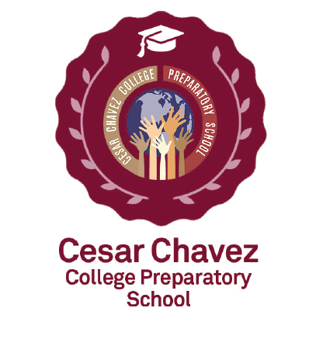
Cesar Chavez College Preparatory School\
2400 Mock Road
Columbus, Ohio 43219
(IRN 010036)

ANNUAL REPORT
2021-2022

In the face of post-pandemic learning loss, Cesar Chavez maintained its academic performance with a 3 point rise in its Performance Index in the 2021-22 school year. Moreover, the students at Cesar Chavez College Preparatory School kept pace with National cohorts with respect to academic growth as measured by NWEA norm-referenced assessments. Strategies effectively dealing with pandemic learning loss included a July early start to the 2021-22 academic year.

Cesar continues to provide evidence-based curriculla and practices for its diverse student population; facilitated by our 100% Highly Qualified Teachers. At Cesar Chavez, we provide our students with opportunities to establish relationships with their teachers and classmates while introducing them to the expectations and underpinnings of “Real World Learning”. Cesar Chavez has high expectations for achievement for all students. The school has multiple TESOL-certified teachers, providing skilled instruction to its large English Learner population. Free breakfast and lunch are provided, as well as culturally and academically-relevant field trips. We believe that it is critically important for your child’s educational experience that they have a sense that a positive, healthy relationship exists between their parents and the School. This provides them with a sense of security which is a foundation for good learning!

Mission: To make a “World of Difference” in the lives of our students by utilizing evidence-based education practice within an environment high in morals, social standards and care; measured by academic growth metrics.

Vision: To prepare students academically, socially and morally to become effective contributors to society with a focus on Real World Learning and career exploration.

Demographic Data
Enrollment

During the 2021-22 school year, Cesar Chavez College Preparatory School had a total of 300 students.

Students enrolled in grades K-5 were as follows:

Grade K 66

Grade 1st 59

Grade 2nd 54

Grade 3rd 41

Grade 4th 41

Grade 5th 39

Total _____300

Composition
Black 93 %
White 0 %
Multiracial 0 %
Hispanic 7 %

Economically Disadvantaged 100 %
Students with Disabilities 3 %

EDUCATIONAL PHILOSOPHY

Cesar Chavez College Preparatory School is committing to the following:

- Providing a safe, caring and disciplined learning environment.
• Accepting no excuses for any child's failure to learn.
• Expecting and teaching all students to exhibit exemplary behavior.
• Emphasizing academic basics, especially in primary grades.
- Emphasizing only high student achievement based on rigorous, meaningful standards measured frequently (daily).
• Utilizing evidence-based curricula and instructional techniques.
- Employing a mastery model of learning in all academic areas to promote skill generalization.
• Treating parents as customers.
• Freeing teachers from inefficiencies and equipping/coaching them to teach all students to high levels of academic success.
- Utilizing the latest advances in technology.

The educational philosophy of the program states that every child can learn if taught appropriately. In other words, children who fail have been failed by the instruction to which they have been submitted. Equipped with a proven curriculum, school staff must follow successful instructional practices, evaluate each child daily, and as needed, alter ineffective teaching practices to meet the needs of every child. The school emphasizes basic skill development and mastery at every stage so as to make it most probable that skills will be applicable and generalizable beyond the immediate instructional setting.
Cesar Financial Plan:

Total Operating Revenues $3,181,935
Total Operating Expenditures $3,510,238
Non Operating Revenues $1,171,455.
Beginning Cash $195,481
Ending Cash $902,042

Academic Assessment and Accountability
Seventy six percent (76%) of Cesar Chavez students are English Learners. The students continue to show significant, consistent gains. We continuously focus on advancing our students to the next level and utilize evidence-based best practices to accomplish this aim. Through the use of ongoing Benchmark formative assessments and MAP interim assessments, Cesar Chavez students predominantly exceeded projected growth targets in ELA and Math for the 2021-2022 year (Figure 1). It is our goal to continue to move our students forward through our 100% Highly Qualified Teachers, Data-Driven Decision making, Achievement Teams, MTSS program and ongoing Aligned Benchmark Assessments.
Figure 1------= Expected academic gains for the respective grade cohort: Fall 2021 to Spring 2022 MAP Assessments.
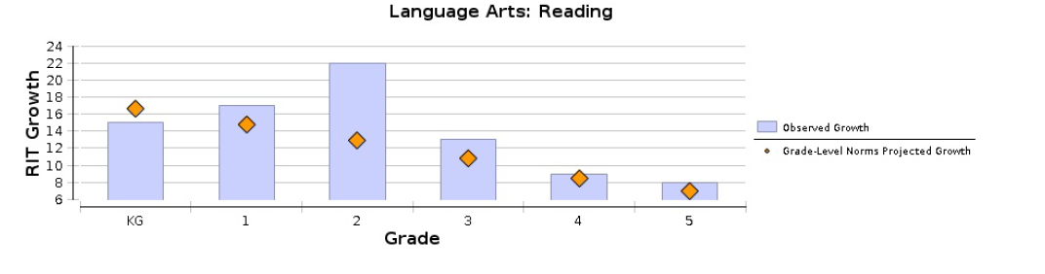
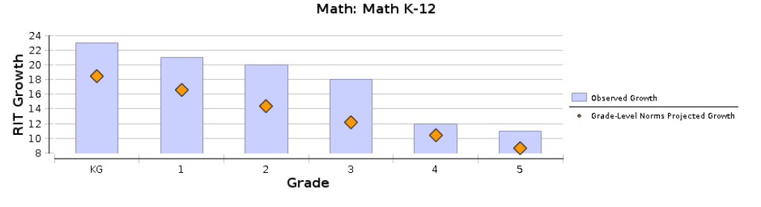
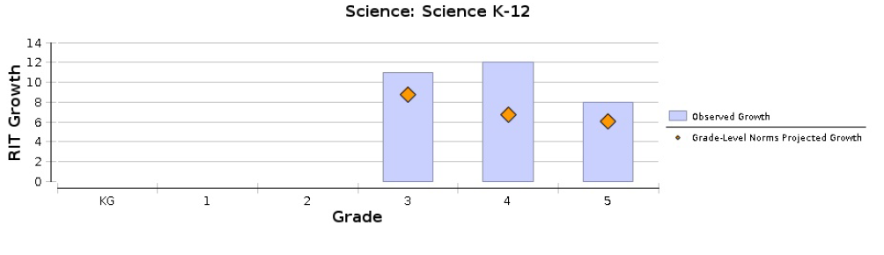
2021-22 STATE OF OHIO
ASSESSMENTS
Grade | Subject | Percent  Proficient
3 | Reading | 35
 | Math | 59
4 | Reading | 55
 | Math | 48
5 | Reading | 47
 | Math | 39
 | Science | 28

Governance: – The Five member Governing Board of the Cesar Chavez College Preparatory School:
- Gloria Anderson
- Dr. Dennis McKay
- Louis Morgan
- Dr. Kenny Roman
- Shonen Thomas

Program Location: 2400 Mock Road, Columbus, Ohio 43219

